Graph Theory - Tutorial 3
SMA116 – Discrete Mathematics 1B
Question 1
Suppose a computer takes 1 microsecond (a millionth of a second) to execute each operation. How long will it take for the computer to execute each of the following numbers of operations?
- 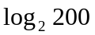 | - 200
- 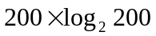 | - 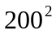
- 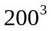 | - 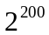
Question 2
For each of the following algorithm segments, assume that n is a positive integer and
- Compute the number of additions, subtractions, multiplications, divisions, and comparisons that must be performed when the algorithm segment is executed;
- Show that the algorithm segment has the specified complexity.
- for 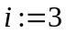 to 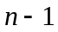
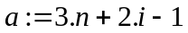
next i
complexity: O(n)
- 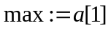
for 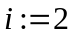 to
if 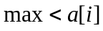 then 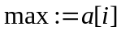
next i
complexity: O(n)
- for 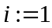 to 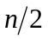
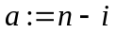
next i
complexity: O(n)
- for to n
for 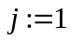 to 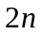
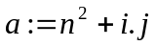
next j
next i
complexity: O(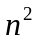)
- for 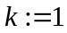 to
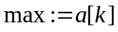
for 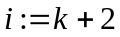 to n
if then
next i
next k
complexity: O()
- for to n
for 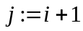 to n
if 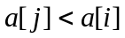 then do
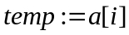
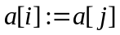
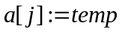
end do
next j
next i
complexity: O()
- for to n
for to 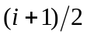
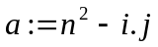
next j
next i
complexity: O()
Question 3
Calculate for
- 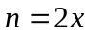
When the value of n given in parts (a) and (b) increases by a factor of 2, by what factor does increase?
What does this tell you about the relationship between the two values of n, and the corresponding values of ?
Question 4
Calculate for
- 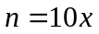
When the value of n given in parts (a) and (b) increases by a factor of 10, by what factor does increase?
What does this tell you about the relationship between the two values of n, and the corresponding values of ? Consider what it means in terms of Question 3 – how does increasing n by a factor of 2 compare to increasing it by a factor of 10?
Question 5
Given that 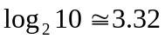 and 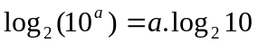for all real numbers a, calculate:
- 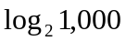 | - 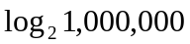
- 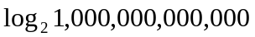
Question 6
Given your answers in Question 5, generalise your results and comment on the following:
- Consider 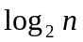. If we square n, by what factor does increase?
- By what factor does increase if we raise n to the tenth power.
- When n is increased from 100 to 10,000,000,000, by what factor is increased?

